**CSC 1310 LAB 10**

**MINIMUM HEAP**

# Minimum Heap of CREATURES



Write an **ArrayMinHeap** class that implements a minimum heap of creatures where the minimum is based on the creature’s name. You are given the Creatures class, CreatureBinaryTree class, and the Zoo (driver) source file. The **logic** of the Zoo.cpp source file should not be changed.

**Your program should not use the CreatureBinaryTree class at all – I only provide it because the current version of Zoo uses this class. Your program should use the ArrayMinHeap class instead.**

# ARRAYMINHEAP

Refer to the sample ArrayMinHeap class demonstrated in class to help you write your own class.

**Private attributes:**

* Creature *heapArray;
* int capacity;
* int heap_size;

**Private functions:**

* swap
* parent
* left
* right

**Public functions:**

* constructor (accepts an integer capacity & creates heapArray based on this capacity)
* destructor (releases heapArray memory)
* minHeapify (recursive method to adjust the heap to make sure all nodes follow the min-heap rule)
* peek (returns root creature)
* remove (remove minimum element (or root) from min heap)  
  Note – you will need to return a Boolean from this function to indicate if a creature was removed (none will be removed if there are no nodes). Also, you will need to return the creature removed. I suggest passing the creature to be removed by reference and returning the Boolean.  
  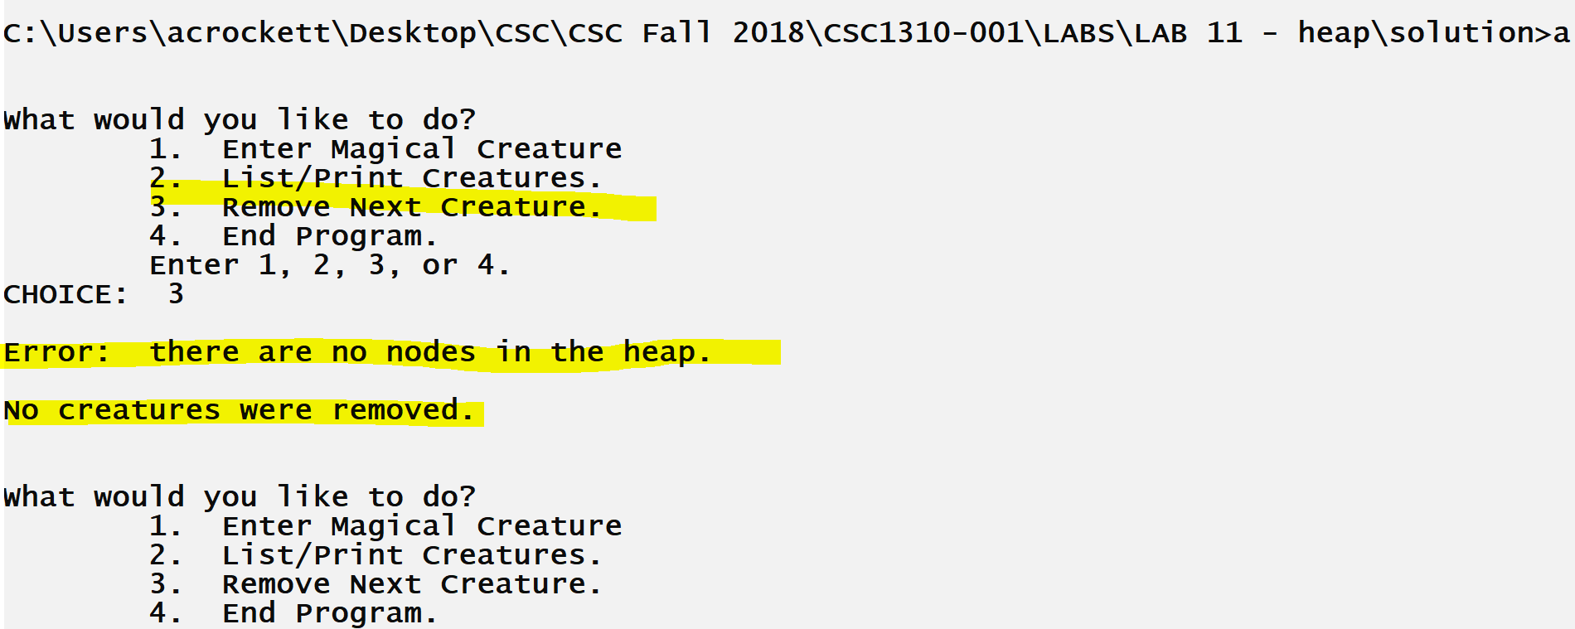
* insert (insert new creature in heap – Creature is sent to this function)
* resizeArray (make an array 2 times as big as original)
* isEmpty (returns true if heap_size is zero and false otherwise)
* getNumberOfNodes (returns heap_size)
* getHeight (returns the ceiling of log base 2 of heap_size plus 1)
* display (traverses the array starting at 1st element and prints out the name of each creature – one per line)
* saveToFile (traverses the array starting at 1st element and calls the printCreatureToFile function sending "savedCreatures.txt" to this function.

# zoo.cpp

Modify the given **Zoo.cpp** to create a heap of creatures instead of a binary tree. You will create a minimum heap that has a capacity of **100** creatures.

Add an additional option (option 3) to remove the next creature. Remember that when you remove from the heap you always remove the root – which is the creature that comes first in the alphabet in this program.

Refer to the sample output below to see how your program should work.

# Sample Output

User input is highlighted in **yellow**.

**What would you like to do?**

**1. Enter Magical Creature**

**2. List/Print Creatures.**

**3. Remove Next Creature.**

**4. End Program.**

**Enter 1, 2, 3, or 4.**

**CHOICE: 1**

**Do you want to enter the creature(s)**

**1. Manually?**

**2. From a file?**

**ENTER 1 or 2: 2**

**What is the name of the file you want to read from?**

**FILENAME: creatureFile.txt**

**6 creatures from creatureFile.txt have been read from the file.**

**What would you like to do?**

**1. Enter Magical Creature**

**2. List/Print Creatures.**

**3. Remove Next Creature.**

**4. End Program.**

**Enter 1, 2, 3, or 4.**

**CHOICE: 2**

**Banshee**

**Beholder**

**Mike Wazowski**

**Sasquatch**

**Troll**

**Unicorn**

**What would you like to do?**

**1. Enter Magical Creature**

**2. List/Print Creatures.**

**3. Remove Next Creature.**

**4. End Program.**

**Enter 1, 2, 3, or 4.**

**CHOICE: 3**

**You have removed Banshee**

**What would you like to do?**

**1. Enter Magical Creature**

**2. List/Print Creatures.**

**3. Remove Next Creature.**

**4. End Program.**

**Enter 1, 2, 3, or 4.**

**CHOICE: 2**

**Beholder**

**Sasquatch**

**Mike Wazowski**

**Unicorn**

**Troll**

**What would you like to do?**

**1. Enter Magical Creature**

**2. List/Print Creatures.**

**3. Remove Next Creature.**

**4. End Program.**

**Enter 1, 2, 3, or 4.**

**CHOICE: 8**

**Your choice was invalid. Choose a number 1 through 4.**

**CHOICE: 4**

**Would you like to save your creature list to a file? (y or n) y**

**Beholder was printed to savedCreatures.txt**

**Sasquatch was printed to savedCreatures.txt**

**Mike Wazowski was printed to savedCreatures.txt**

**Unicorn was printed to savedCreatures.txt**

**Troll was printed to savedCreatures.txt**

**GOODBYE!**

# What to turn in

Please put the files below in a zipped folder and upload to ilearn submission folder.

* **ArrayMinHeap.h**
* **Creature.cpp**
* **Creature.h**
* **creatureFile.txt**
* **Zoo.cpp**